Experiment-1

Aim:

To Develop and design a mobile or web application to change background color and menu.

Procedure:

1. Choose any reference image. And align it properly.
2. Recreate your image.
3. Add some details from the reference.
4. Select the first frame and change the background color.

Screenshot:

1.Before

2.Output:

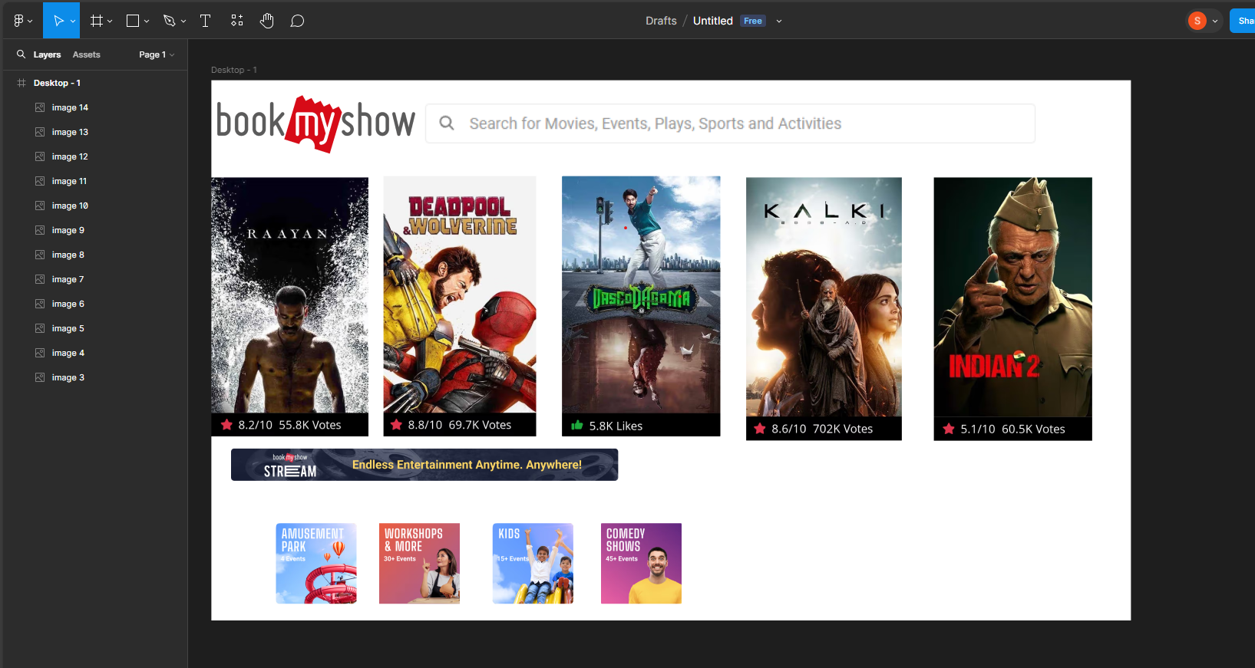

Result:

Thus the background color and menu of the application is changed.